# Concept

The concept of the story was heavily influenced by the movie *Groundhog Day* and the game *Spooky’s Jump Scare Mansion*. In the story, the character of the game ends up inexplicably trapped inside a large room without any means of escaping. Whenever they reach the “end” of the room, they simply end up coming through the door they originally came in through at the beginning of the game. As the character goes through subsequent loops, they will discover evidence of the characters that came before them and their gradual descent into insanity and hopelessness.

# Design Doc

## Story Premise

The player controls an explorer who sets out to find a treasure inside an old, supposedly cursed temple. The story begins at the moment when the character first sets foot inside the temple but the cave-in behind them leaves them trapped and unable to leave. With no choice to go anywhere but forward, the character advances and finds themself in a large room with a large altar in the middle. As the room doesn’t seem to have anything of value stored inside, the character moves forward… and finds themself at the start of the room again. As the story progresses, the character realizes that they are stuck inside an infinitely-looping room and, on subsequent loops, they start finding more and more evidence of the explorers who came before and what happened to them when they were trapped. Eventually, the player character will be presented with an in-game choice to pick up the gold, thus letting their greed consume them like it did with the explorers before, pick up an ax and destroy the temple, thus succumbing to the insanity and bloodlust, or to keep going and persist and eventually find their way out of the temple again.

## Player Identity

The player assumes the role of an explorer who sets out to find an ancient, treasure-filled temple, unaware of the terrible curse that lay upon the temple itself. We wanted to keep the identity vague enough so that the players can immerse themselves in the experience and identify with the silent protagonist.

## Objects/Props of Importance

There are several noteworthy objects that serve to advance the plot.

The main one is the doorway that keeps the player inexplicably stuck inside the loop. As there are no other ways to progress, the player will have no choice but to walk through the doorway multiple times.

The ax is meant to serve as a “temptation” for the player. We assume that the player will assume that the ax is necessary for the progression of the narrative and will thus pick it up and start using it, inadvertently dooming their character to being stuck in the loop forever.

The gold that the player will encounter along the way serves as yet another temptation for the player. If the player assumes that the gold is the final goal of the game, we assume that the player will try to interact with it and, once again, achieve the “bad ending”.

There will also be several other objects such as skeletons, rubble and signs of decay to convey the idea of other characters visiting the temple beforehand and going through the same motions.

## Anticipated player flow through environment

We expect the player to navigate through the first loop relatively quickly. Since everyone in the class knows about the nature of the assignment, we predict that they would try to pay attention to the environment. Although that may not necessarily be the case and they might try to approach the experience from the point of view of a normal gamer who has no idea about the nature of the game, we’re banking that some of those preconceptions would bleed through.

When the players go through the first loop and re-enter the level from the beginning, we expect them to feel confused as to what happened and whether they did something wrong during their “first playthrough”. At that point, we expect the players to pay a little more attention to the level to see if there was anything that they’ve missed on their first walk through the game. And since they will be going through the same level multiple times, we expect them to identify the new objects within the environment with relative ease, depending on their perceptiveness and the size of the object, at least.

Lastly, we also wanted to challenge some of the player’s preconceptions by handing them a weapon during the later loops. We expect that the player would start using the weapon and thus achieve the “bad” ending at the end of the experience. We expect that most of the players would fall into that “trap” on their first playthrough.

# Level Design Sketches/Related Documents

The sketches and related documents will be located in the “Media” folder inside the google drive.

**Game Flow:**

Loop 1: The Basic Level layout is rendered. If we consider the level to be a hypothetical part of a larger game, the loop 1 starts after a player finished navigating a series of caverns which led them to the temple. They start the level after that sequence and, if they try to turn back and go through the way they came in, they’ll discover that the entrance was caved in and is currently blocked by rocks. Due to the lack of other options, the player is forced to proceed forward through the temple.

Loop 2: Same as Loop 1. The level layout is completely the same as in Loop 2. At this point, we assume that the player will think one of two things: that they’re entered another section of the temple that’s completely similar or, what’s more likely, that they’re inside a loop.

* Note: We thought that most people would realize something is off, and pay more attention to each game object at this stage.

Loop 3: Subtle Changes, I.E. One Statue has fallen. At this point, we start changing the objects within the scene. Starting small and gradually changing more and more objects to convey the idea that the player character is stuck inside the temple and that they are going through various time periods of the temple’s lifespan.

Loop 4-5-6: Increased signs of aging all around the room, further reinforcing the idea.

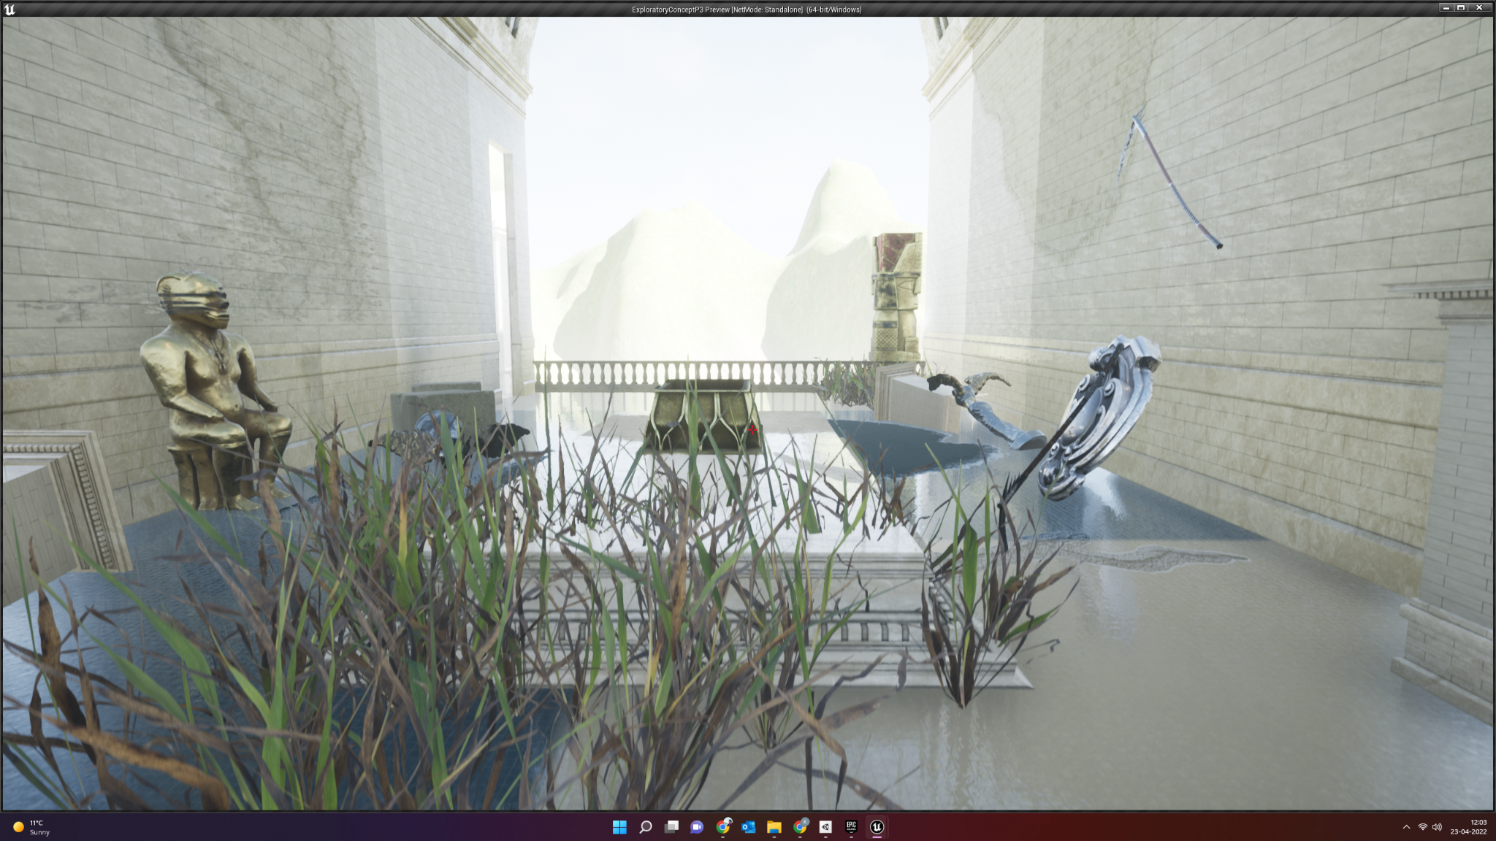

Loop 7: The golden statue is right at the start of the room, aging continues. This is to reinforce the idea of a presence of a supernatural force and to make the temple feel more eerie. Moving the statue behind the gateway through which the player loops serves two purposes. During the playtest, the subject failed to notice the statue as they didnt’ turn around. However, if the player is curious and is constantly looking around with every subsequent loop, they will spot the statue.

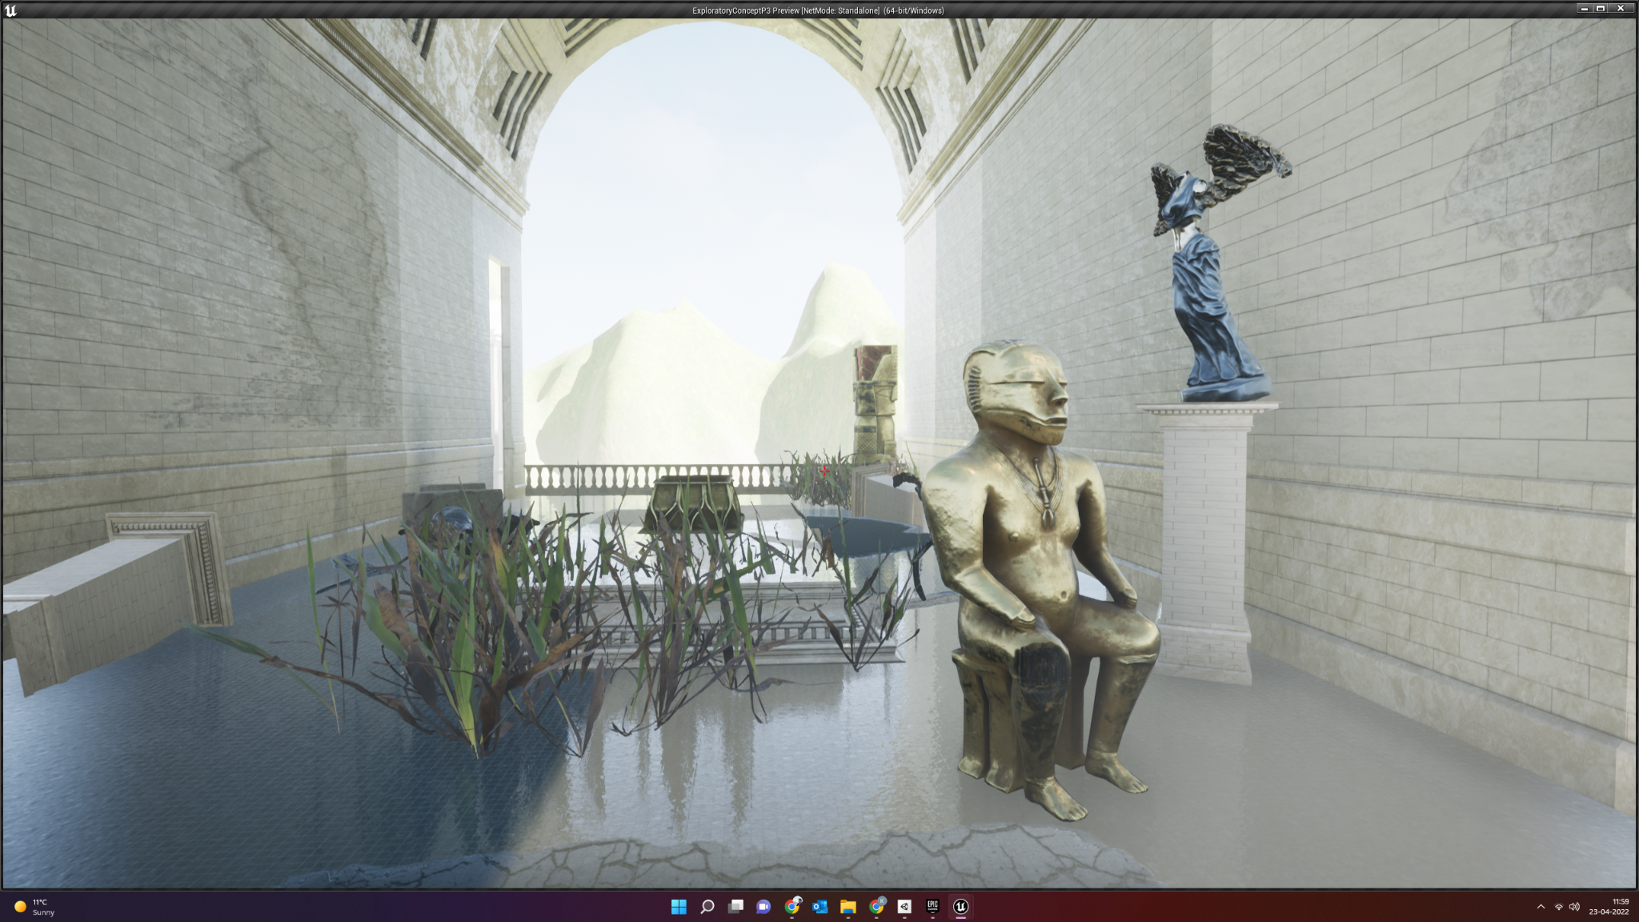

Loop 8: The room is back to normal but is filled with the golden statue looking at the chest in the middle. Render Gold in chest. If the player picks up the gold == Loose Condition, remove the portal. At that point, should the player pick up the gold, they will be stuck inside the room and a timer will start. Upon its expiration, the game ends, suggesting that the player’s character got stuck inside the temple due to their own greed.

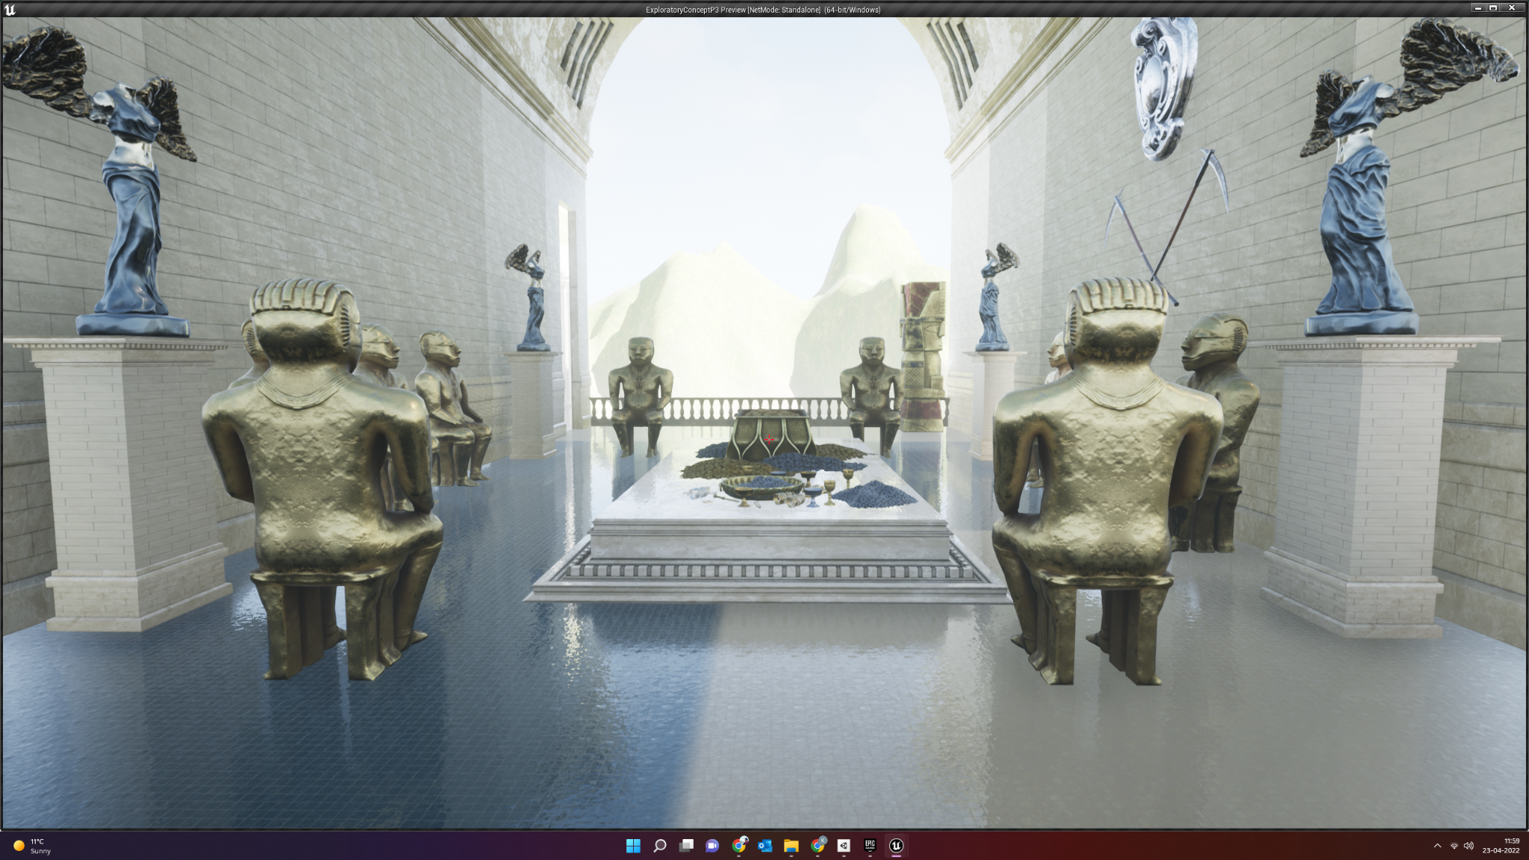

Loop 9: Glowing portal. If the player picks up the gold == Loose Condition, remove the portal. This is the final loop of the game and the last chance for the player to pick up the gold to achieve the bad end. If the player ignores the gold, they will be teleported far outside of the temple and into a garden somewhere in the mountains. Upon looking back, they’ll see nothing but an empty archway and no apparent way back to the temple. After about ten seconds, the screen will fade to black, implying that the player character managed to escape the looping temple and survived.

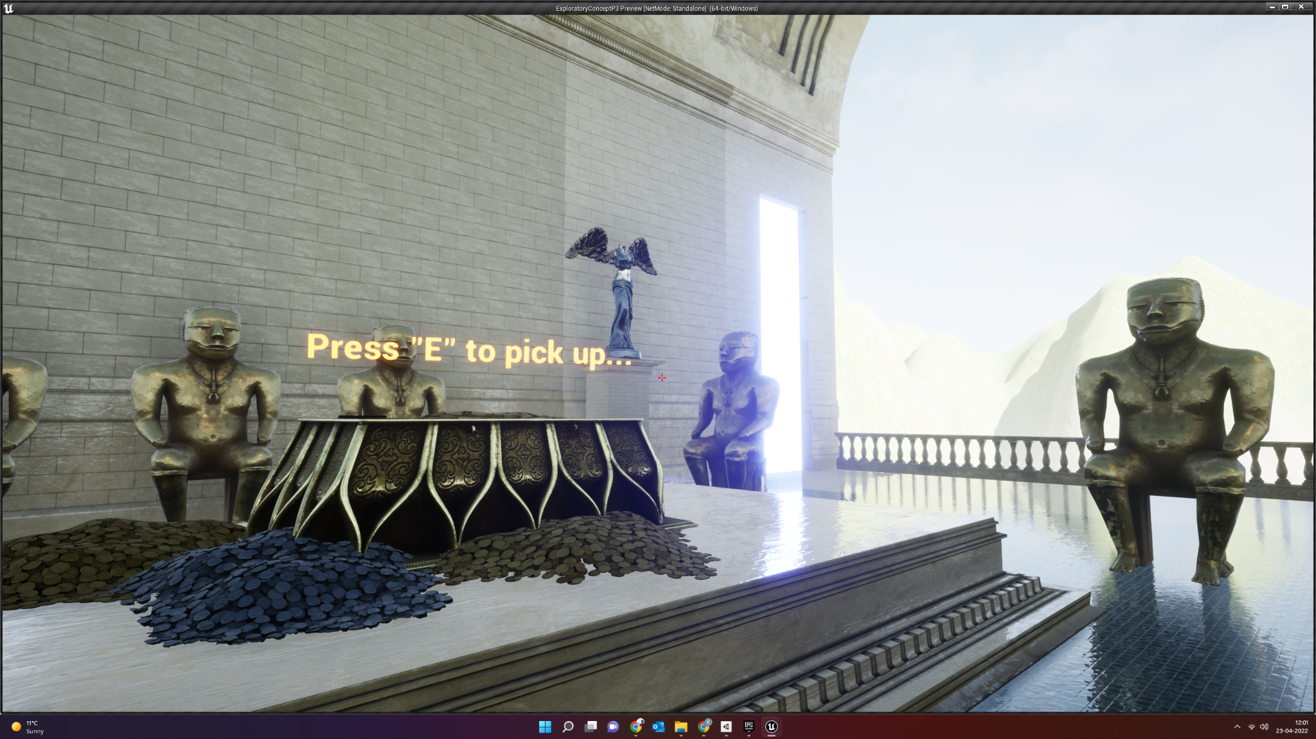

Win Conditions: Player doesn't pick up the gold, escapes the loop, comes out to a garden.

Loose Condition: Player picks up the gold, gets stuck in loop forever.

Assets used:

* <https://www.unrealengine.com/marketplace/en-US/product/e4494c76c3b348aba7ef9b263a6dd496>
* <https://www.unrealengine.com/marketplace/en-US/product/639e2fdbb81d4d59860e87e701c89679>
* <https://www.unrealengine.com/marketplace/en-US/product/sun-temple>

Sound effects used:

* <https://www.youtube.com/watch?v=jAebfIiXllY&ab_channel=BurghRecords>
* <https://www.youtube.com/watch?v=l2OQbA3r78M&ab_channel=ElMiusikman>